**A**

**PROJECT REPORT**

**ON**

**Courier Web Software**

**SUBMITTED BY**

Avinash Shiyani

Bhavya Shah

**ACADEMIC YEAR 2021-24**

**T.Y B.C.A. SEM - 5**

**UNDER THE GUIDANCE OF**

Meet Thakar

Sawan Sanghvi

**SMT. C.Z.M GOSRANI B.C.A. COLLEGE**

**JAMNAGAR**

**SUBMITTED TO**



**A**

**PROJECT REPORT**

**ON**

**Courier Web Software**

**SUBMITTED BY**

Avinash Shiyani  
Bhavya Shah

**ACADEMIC YEAR 2021-24**

**T.Y B.C.A. SEM - 5**

**UNDER THE GUIDANCE OF**

Meet Thakar

Sawan Sanghvi

**SMT. C.Z.M GOSRANI B.C.A. COLLEGE**

**JAMNAGAR**

**SUBMITTED TO**



**SAURASHTRA UNIVERSITY**

**RAJKOT**

ABSTRACT

The Courier Management System (CMS) is a straightforward and easy-to-use web app designed to streamline courier services. Its main purpose is to simplify the entire process of managing packages and deliveries, making it more efficient and reliable.

One of the most significant advantages of the CMS is its real-time tracking feature. Both senders and recipients can easily track their packages using unique tracking numbers. With the CMS, registering a new package is a breeze. Users can enter sender and recipient information, package contents, and delivery preferences with just a few clicks. The CMS also takes care of inventory management, keeping track of incoming and outgoing packages to maintain organization and prevent losses.

In summary, the Courier Management System is a user-friendly solution that simplifies courier operations. Its features, such as package registration, optimized delivery routes, real-time tracking, automated notifications, and inventory management, make it an indispensable tool for enhancing efficiency and customer satisfaction in the courier industry.

**ACKNOWLEDGEMENT**

*"It is not possible to prepare a project report without the assistance & encouragement of other people. This one is certainly no exception."*

We feel great pleasure in submitting this project report as a part of our B.C.A. Semester 5 curriculum. A practical study plays an important role.

For the successful completion of our project, we would especially like to thank our parents and teachers for their support and unconditional help. We would also like to thank our Project Guide **MR MEET** **THAKAR** and DocumentGuide **MR SAWAN SANGHVI** for their constant support and help in implementation of this project.

We are also thankful to our Principal Ma'am, **Ms. Hetal G. Savla** for all the facilities they provided throughout our semester and for encouraging us to take up this activity.

Lastly, we would also like to thank the faculties and staff members of Smt. C.Z.M. Gosrani B.C.A. College, Jamnagar.

# **PROJECT PROFILE**

|  |  |  |
| --- | --- | --- |
| STUDENT INFORMATION | | |
| Name  Avinash Shiyani  Bhavya Shah | **Enrollment Numbers**  003203212589  003203212587 | |
| PROJECT DETAILS | | |
| Project Title | Courier Web Software | |
| Duration | 4 Months | |
| Name of Project | Courier Hub | |
| Platform | PHP  MYSQL | |
| Team Size | 2 | |
| GUIDE INFORMATION | | |
| Name of Guide | | Meet Thakar  Sawan Sanghvi |

# **INDEX**

|  |  |  |
| --- | --- | --- |
| Chapter | Title | Page No. |
| 1 | **Overview of the accepted SDLC Model** |  |
| 2 | **Requirement Gathering and Analysis** |  |
|  | 2.1 Organization Details |  |
| 2.2 Meetings |  |
| 2.3 Type of Project |  |
| 2.4 Method of collecting requirements |  |
| 3 | **System Requirement Specification** |  |
|  | 3.1 Introduction |  |
| 3.1.1 Purpose |  |
| 3.1.2 Scope |  |
| 3.1.3 Operating Environment |  |
| 3.1.4 User classes |  |
| 3.2 System Modules |  |
| 3.3 External Interface Requirements |  |
| 3.3.1 Hardware Interface Requirements |  |
| 3.3.2 Software Interface Requirements |  |
| 3.3.3 User Interface Requirements |  |
| 4 | **System Analysis and Modelling** |  |
|  | 4.1 Normalization |  |
| 4.2 Data Dictionary |  |
| 4.3 Data Flow Diagram |  |
| 4.4 E-R Diagram |  |
| 4.5 Use-case Diagram |  |
| 4.5 Gantt Chart |  |
| 5 | **Test Cases** |  |
| 6 | **Screenshots** |  |
| 7 | **Limitations and Future Enhancements** |  |
| 8 | **Conclusion** |  |
| 9 | **References and Bibliography** |  |

**CHAPTER 1**

**OVERVIEW OF THE ACCCEPTED SDLC MODE**

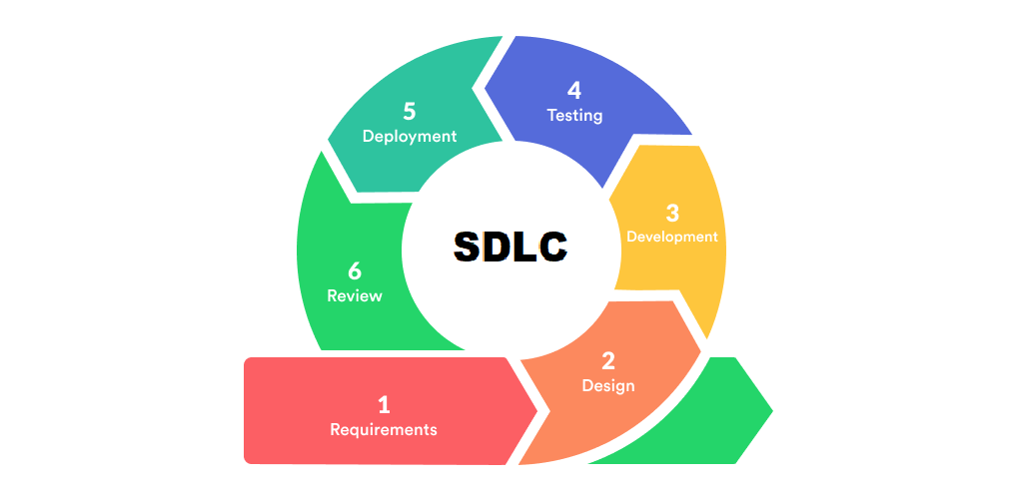

**SDLC model**

* Each step of the SDLC lifecycle is followed in a linear approach.
* Upon the completion of the step , next step started.
* Cannot go to the previous step.

**CHAPTER 2**

**REQUIREMENT GATHERING AND ANALYSIS**

1. **Organization details**
   * **Name of organization:**
     + Online men’s wear
   * **Brief details of the organization:**
     + Onlione men’s wear is a online cloths shopping company which Povides facility of men’s wear cloths.
2. **Meetings**
   * **Meeting with a owner:**
     + **Name of the owner:**
       - Mr.jaydeep desai
     + **Requirements of the owner in their own words:**
       - Mr jaydeep wants a website where customer can see many type of men’s cloths and order the cloths.
3. **Type of project**
   * The system will be in form of web application.
   * Usres will access it with internet.
4. **Method of collecting requirements**
   * Via interviewing the user

**CHAPTER 3**

**SYSTEM REQUIREMENT SPECIFICATION**

* 1. **Introduction**

Online men’s wear shopping is online clothes shopping from which user can buy clothes.it also allows user to register and login to the website .

* + 1. **Purpose**

The Main purpose of this project is to provide a branded clothes in Reasonable price and user friendly environment so user can easily to buy branded clothes.

The addition and deletion of the module in software can be easily adjusted.

This project can save money and effort in managing the record.

* + 1. **Scope**
       - Purchasing and selling products and services over the internet without the need of going physically to the market is what online shopping all about. Online shopping is just like a retail store shopping that we do by going to the market, but it is done through the internet. Online shopping has made shopping painless and added more fun. Online stores offer product.
    2. **Operating Environment**
       - **Windows : 7/8/10/11**
       - **Minimum RAM : 512mb or higher**
       - **Storage : 2GB or higher**
    3. **User Classes**
       - **Admin**
         * Admin must be capable to manage Database & user
         * Admin must be capable to manage Products.
       - **User**
         * User should have basic idea about shopping.
         * No specific knowledge or skills are required from the users .
  1. **System Modules**
     + **Admin Module**
       - This module do login, add user, update user and delete user.
       - Add category ,delete category ,update category
     + **User Module**
       - This module do register, login, view clothes , purchase clothes
  2. **External Interface Requirements**
     1. **Hardware Interface Requirements**
        + Minimum 512MB RAM
        + 10GB storage
        + 2 vCPU
     2. **Software Interface Requirements**
        + PHP
        + MySQL
        + Any Internet Browser
     3. **User Interface Requirements**
        + Stable internet connection

**CHAPTER 4**

**System Analysis and Modelling**

**4.1 NORMALIZATION:**

Normalization is the process of organizing the [columns](https://en.wikipedia.org/wiki/Column_(database)) (attributes) and [tables](https://en.wikipedia.org/wiki/Table_(database)) (relations) of a [relational database](https://en.wikipedia.org/wiki/Relational_database) to reduce [data redundancy](https://en.wikipedia.org/wiki/Data_redundancy) and improve data integrity.

* **Normalized Form:**

1. **Normalization:**

|  |  |  |
| --- | --- | --- |
| Adminid  (PK) | Username | Password |
| 1 | admin | admin |

1. **Table Name : Admin_master**

**Primary key: Adminid**

1. **Table Name : category_master**

**Primary Key: Catagoryid**

|  |  |  |  |
| --- | --- | --- | --- |
| Categoryid (PK) | CategoryName | Decription | Img |
| 1 | Jeans | Fine Denim Jeans to wear | Jeans.jpg |
| 2 | Shirts | New Branded Cotton shirts | 1594.jpg |
| 3 | T-shirts | Cool T-Shirts Sporty Look | images.jpg |

1. **Table Name :**

**Primary Key:**

|  |  |  |  |  |  |  |  |  |  |
| --- | --- | --- | --- | --- | --- | --- | --- | --- | --- |
| CustomerId | CustomerName | Address | City | Email | Mobile | Gender | BirthDate | UserName | Password |
| 1 | Tabrej | dhuvav | Jamnagar | abc@gmail.com | 8888999955 | 8888999955 | 2022-09-27 | asd | asd |

1. **Table Name :**

**Primary Key:**

|  |  |  |  |  |  |  |  |  |
| --- | --- | --- | --- | --- | --- | --- | --- | --- |
| ItemId | CategoryId | ItemName | Description | Size | Image | Price | Discount | Total |
| 1 | 1 | Denim Jeans | Nice Look Boot Cut | 32 | Jeans.jpg | 1200 | 100 | 1100 |
| 2 | 2 | Cotton Shirts | Nice Cotton Shirts | Medium | 1594.jpg | 690 | 40 | 650 |
| 3 | 3 | Sport T-Shirts | Cool Sport T-Shirts in all colours | Large | t-shirt.jpg | 600 | 100 | 500 |

**4.2 Data Dictionary:**

**1) Table Name: Admin_master**

|  |  |  |
| --- | --- | --- |
| Columname | Datatype | Constrain |
| Adminid | Int | Primary key |
| Username | varchar |  |
| password | varchar |  |

**2)Table Name: Category_master**

|  |  |  |
| --- | --- | --- |
| Columname | Datatype | Constrain |
| CategoryId | Int | Primarykey |
| CategoryName | Varchar |  |
| Description | Varchar |  |
| Iamge | Varchar |  |

**3)Table Name:Customer_registation**

|  |  |  |
| --- | --- | --- |
| Columname | Datatype | Constrain |
| CustomerId | Int | Primarykey |
| CustomerName | Varchar |  |
| Address | Varchar |  |
| City | Varchar |  |
| Email | Varchar |  |
| Mobile | Bigint |  |
| Gender | Varchar |  |
| BirthDate | Date |  |
| UserName | Varchar |  |
| Password | Varchar |  |

**4)Table Name:Feedback_master**

|  |  |  |
| --- | --- | --- |
| Column Name | Data type | Constrain |
| FeedbackId | Int | Primary key |
| CustomerId | Varchar |  |
| Feedback | Varchar |  |
| Date | Date |  |

**5)Table Name:offer_master**

|  |  |  |
| --- | --- | --- |
| Column Name | Data Type | Constrain |
| OfferId | Int | Primary key |
| Offer | Varchar |  |
| Detail | Varchar |  |
| Valid | Date |  |

**6)Table Name:Item_master**

|  |  |  |
| --- | --- | --- |
| Column Name | Data Type | Constrain |
| ItemId | Int | Primary key |
| CategoryId | Int |  |
| ItemName | Varchar |  |
| Decription | Varchar |  |
| Size | Varchar |  |
| Image | Varchar |  |
| Price | Float |  |
| Discount | Float |  |
| Total | Float |  |

**7)Table Name:Shopping_cart**

|  |  |  |
| --- | --- | --- |
| Column Name | Data | Constrain |
| CartId | Int | Primary key |
| CustomerId | Int |  |
| ItemName | Varchar |  |
| Quantity | Int |  |
| Price | Float |  |
| Total | Float |  |
| OrderDate | Date |  |

**4.3 Data flow diagram:**

**4.3.1 Context Diagram:**

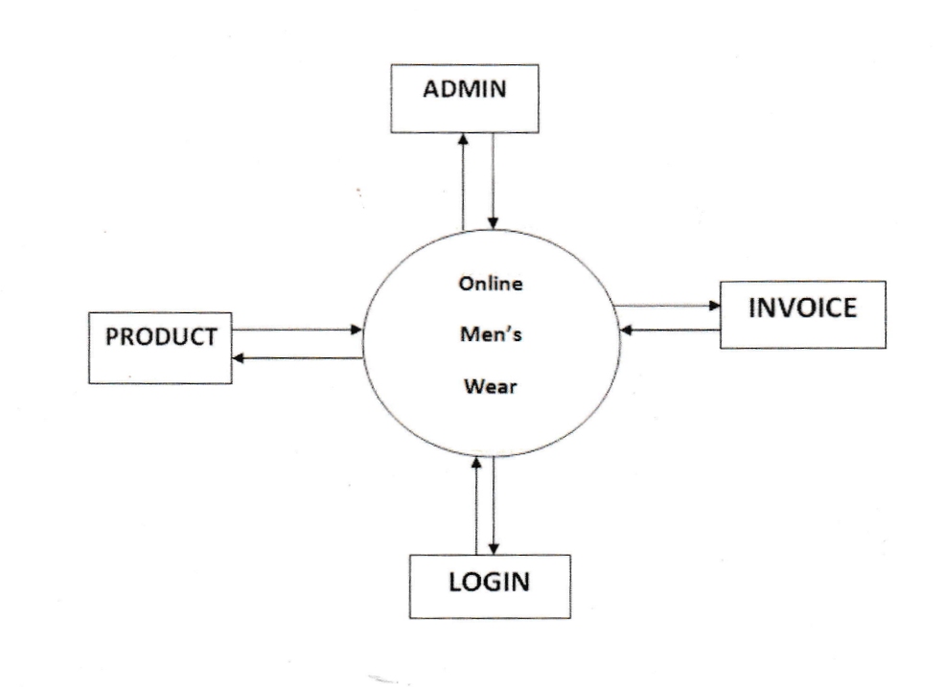

* + 1. **Zero Level Diagram (0-level Diagram)**



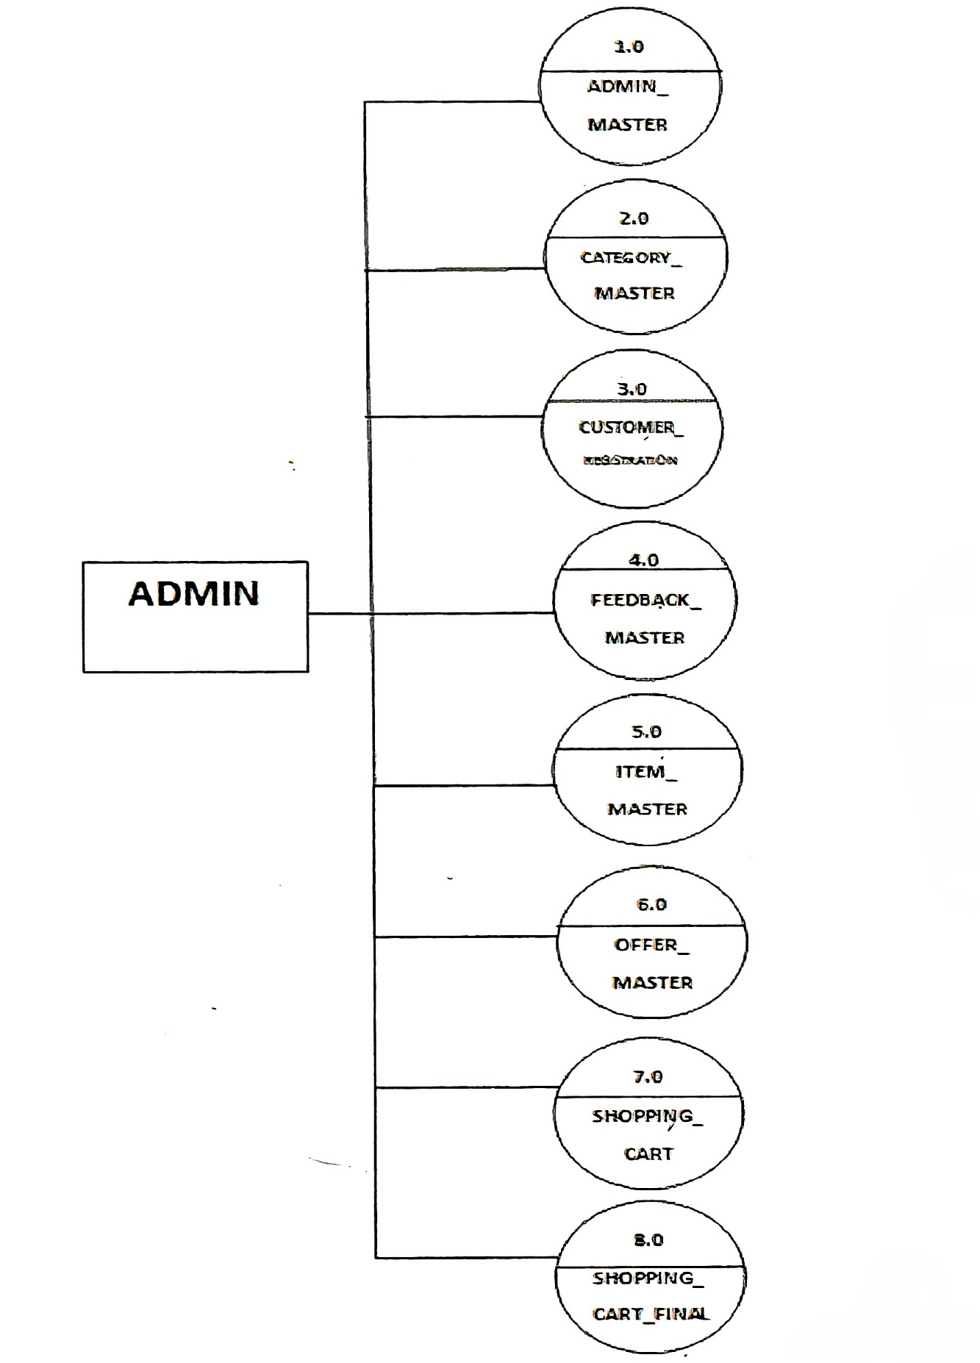



* + 1. **First Level Diagram (1-level Diagram)**



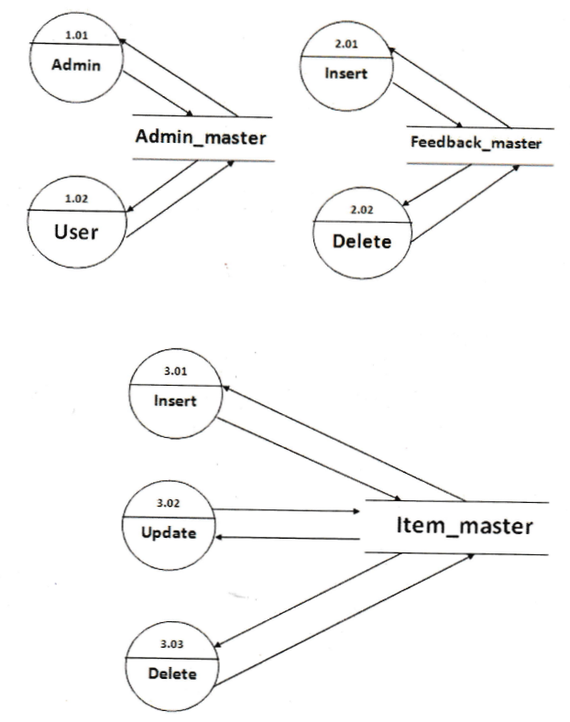

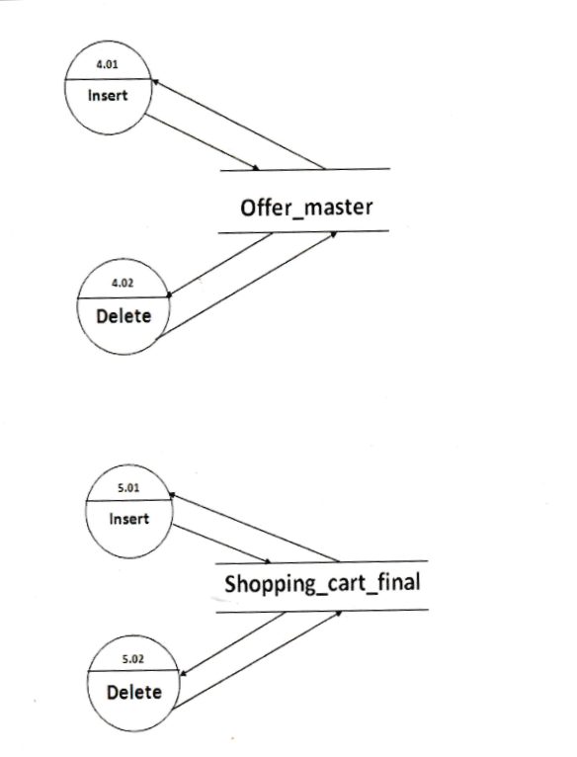

* 1. **E-R diagram**

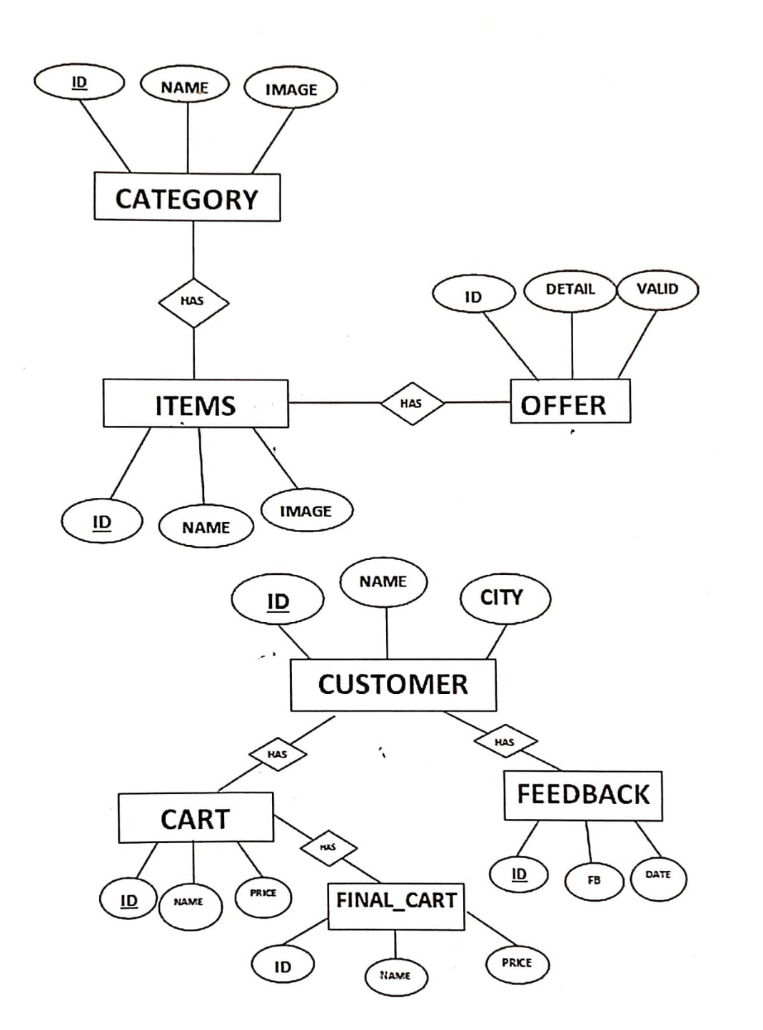

* 1. **USE-CASE diagram**
* **Admin**

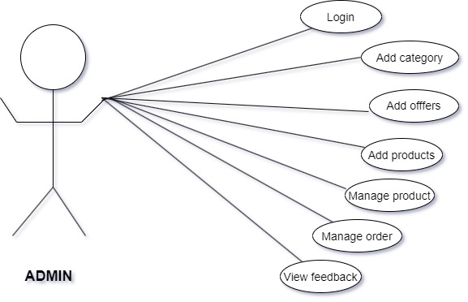

* **User**

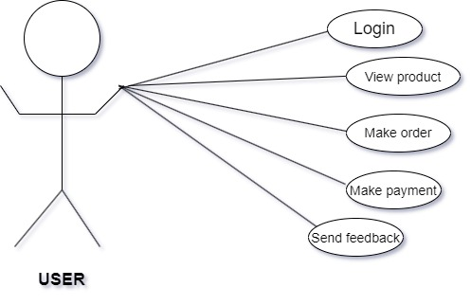

* 1. **Gantt chart**

-Expected time



-Actual time



|  |  |  |  |  |  |  |  |
| --- | --- | --- | --- | --- | --- | --- | --- |
| **No**  **.** | **Task** | **june** | **July** | | | **august** | **september** |
| 1 | Requirement  Gathering and SRS |  |  |  | | | |
|  | |  | | |
|  | | | | | |
| 2 | System  Analysis |  | | | | | |
| 3 | System  Design |  | | | | | |
| 4 | System  Development |  | | | | | |
| 5 | System  Testing |  | | | | | |
| 6 | documentation |  | | | | | |

**CHAPTER5**

**5.1 Test cases**

|  |  |  |
| --- | --- | --- |
| **TEST CASE NO:**1 | **TEST CASE DESIGN DATE:**  20-JULY-2017 | |
| **TEST TITLE :** USER REGISTETION TEST | **TEST CASE EXECUTION DATE:**  20-JULY-2017 | |
| **DESCRIPTION:** In this test case registration form of project will be tested | | |
| **PRECONDITION:** registration form must be working | | |
| **DEPENDANCIES:** PHP,PDO and MySQL | | |

|  |  |  |  |  |  |  |
| --- | --- | --- | --- | --- | --- | --- |
| **STEP NO** | **TEST STEP** | **TEST DATA** | **EXPECTED RESULT** | **ACTUAL RESULT** | **STATUS**  **(PASS/FAIL)** | **NOTES** |
| 1 | Open the page | User Register form | User Register form is visible | User Register form is visible successfully | Pass | - |
| 2 | Provide user login details | Register. Php | User details is entered | User login details is entered | Pass | - |
| 3 | Click Login button | User registered | Message for user registration successful then open home page. | registration is successful | Pass | - |

|  |  |  |
| --- | --- | --- |
| **TEST CASE NO:2** | **TEST CASE DESIGN DATE:**  20-JULY-2017 | |
| **TEST TITLE :** USER PROFILE REGISTETION TEST | **TEST CASE EXECUTION DATE:**  20-JULY-2017 | |
| **DESCRIPTION:** In this test case profile registration form of project will be tested | | |
| **PRECONDITION:** profileregistration form must be working | | |
| **DEPENDANCIES:** PHP,PDO and MySQL | | |

|  |  |  |  |  |  |  |
| --- | --- | --- | --- | --- | --- | --- |
| **STEP NO** | **TEST STEP** | **TEST DATA** | **EXPECTED RESULT** | **ACTUAL RESULT** | **STATUS**  **(PASS/FAIL)** | **NOTES** |
| 1 | Open the  Profile  page | User  profile Register form | User profile Register form is visible | User Profile  Register form is visible successfully | Pass | - |
| 2 | Provide user profile details | register. Php | User profile details is entered | User profile  details is entered | Pass | - |
| 3 | Before Login register | User profile registered | user registration successful then go for home page. | registration is successful | Pass | - |

|  |  |  |
| --- | --- | --- |
| **TEST CASE NO:3** | **TEST CASE DESIGN DATE:**  20-JULY-2017 | |
| **TEST TITLE :** USER LOGIN TEST | **TEST CASE EXECUTION DATE:**  20-JULY-2017 | |
| **DESCRIPTION:** In this test case login form of project will be tested | | |
| **PRECONDITION:** login form must be working | | |
| **DEPENDANCIES:** PHP,PDO and MySQL | | |

|  |  |  |  |  |  |  |
| --- | --- | --- | --- | --- | --- | --- |
| **STEP NO** | **TEST STEP** | **TEST DATA** | **EXPECTED RESULT** | **ACTUAL RESULT** | **STATUS**  **(PASS/FAIL)** | **NOTES** |
| 1 | Open the  Login  page | User  Login form | User Login form is visible | User Login form is visible successfully | Pass | - |
| 2 | Provide user Login details | login. Php | User Login details is entered | User Login  details is entered | Pass | - |
| 3 | Before Login | User Login | user Login successful then view category page. | Login is successful | Pass | - |

|  |  |  |
| --- | --- | --- |
| **TEST CASE NO:4** | **TEST CASE DESIGN DATE:**  20-JULY-2017 | |
| **TEST TITLE :** ADMIN LOGIN TEST | **TEST CASE EXECUTION DATE:**  20-JULY-2017 | |
| **DESCRIPTION:** In this test case admin login form of project will be tested | | |
| **PRECONDITION:** admin login form must be working | | |
| **DEPENDANCIES:** PHP,PDO and MySQL | | |

|  |  |  |  |  |  |  |
| --- | --- | --- | --- | --- | --- | --- |
| **STEP NO** | **TEST STEP** | **TEST DATA** | **EXPECTED RESULT** | **ACTUAL RESULT** | **STATUS**  **(PASS/FAIL)** | **NOTES** |
| 1 | Open the  admin  Login  page | admin Login form | admin Login form is visible | admin Login form is visible successfully | Pass | - |
| 2 | Provide admin Login details | login. Php | admin Login details is entered | admin Login  details is entered | Pass | - |
| 3 | Before admin Login | admin Login | admin Login successful. | admin Login is successful | Pass | - |

|  |  |  |
| --- | --- | --- |
| **TEST CASE NO:5** | **TEST CASE DESIGN DATE:**  20-JULY-2017 | |
| **TEST TITLE :** category insert TEST | **TEST CASE EXECUTION DATE:**  20-JULY-2017 | |
| **DESCRIPTION:** In this test case category insert form of project will be tested | | |
| **PRECONDITION:** caterogy insert form must be working | | |
| **DEPENDANCIES:** PHP,PDO and MySQL | | |

|  |  |  |  |  |  |  |
| --- | --- | --- | --- | --- | --- | --- |
| **STEP NO** | **TEST STEP** | **TEST DATA** | **EXPECTED RESULT** | **ACTUAL RESULT** | **STATUS**  **(PASS/FAIL)** | **NOTES** |
| 1 | Open the  category insert  page | category insert  form | Category insert form is visible | Category insert form is visible successfully | Pass | - |
| 2 | Provide inserting details | category.Php | Category insert details is entered | Category  inserted | Pass | - |
| 3 | Category insert | Category  insert | Category  Insert successful then redirect this page. | inserting is successful | Pass | - |

|  |  |  |
| --- | --- | --- |
| **TEST CASE NO:6** | **TEST CASE DESIGN DATE:**  20-JULY-2017 | |
| **TEST TITLE :** category update TEST | **TEST CASE EXECUTION DATE:**  20-JULY-2017 | |
| **DESCRIPTION:** In this test case category update form of project will be tested | | |
| **PRECONDITION:** category update form must be working | | |
| **DEPENDANCIES:** PHP,PDO and MySQL | | |

|  |  |  |  |  |  |  |
| --- | --- | --- | --- | --- | --- | --- |
| **STEP NO** | **TEST STEP** | **TEST DATA** | **EXPECTED RESULT** | **ACTUAL RESULT** | **STATUS**  **(PASS/FAIL)** | **NOTES** |
| 1 | Open the  Category update  page | Categor y  update  form | Category update form is visible | Category  update form is visible successfully | Pass | - |
| 2 | Provide updating details | Category  . Php | Category update details is entered | category updated | Pass | - |
| 3 | Category update | Category  update | Category  Update successful then redirect this page. | updating is successful | Pass | - |

**CHAPTER 6**

**SCREENSHOTS**

* **Screen Layout (GUI)**

**1**.**Homepage**:

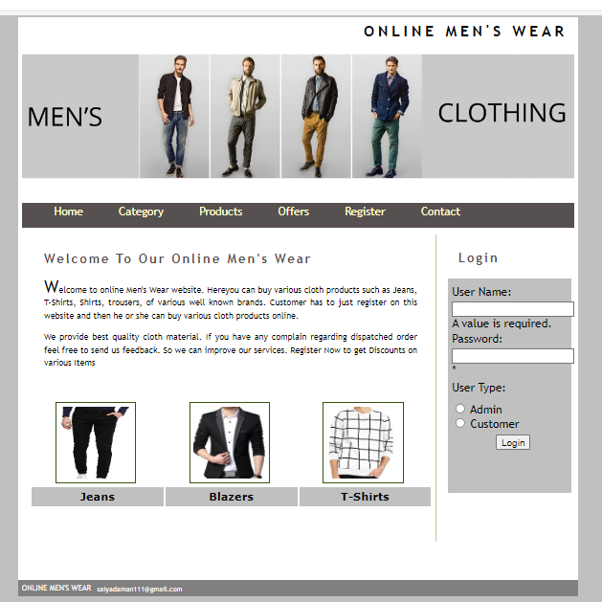

**2.Category:**

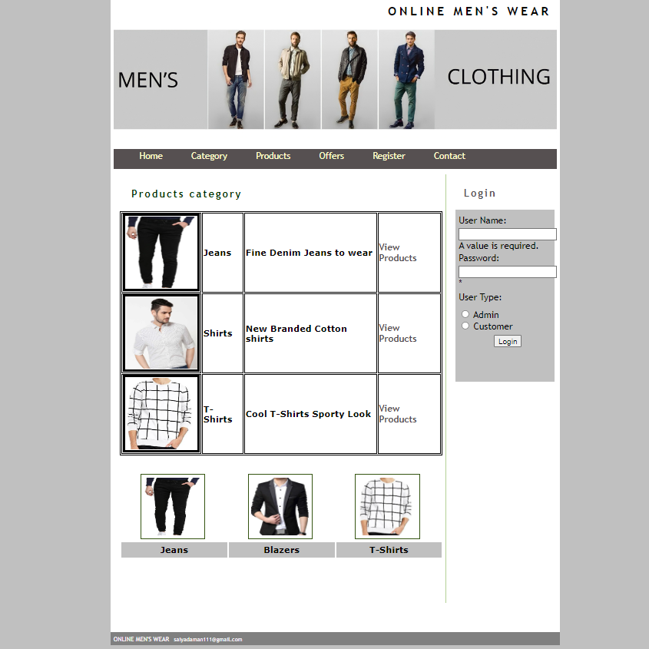

**3. Products**

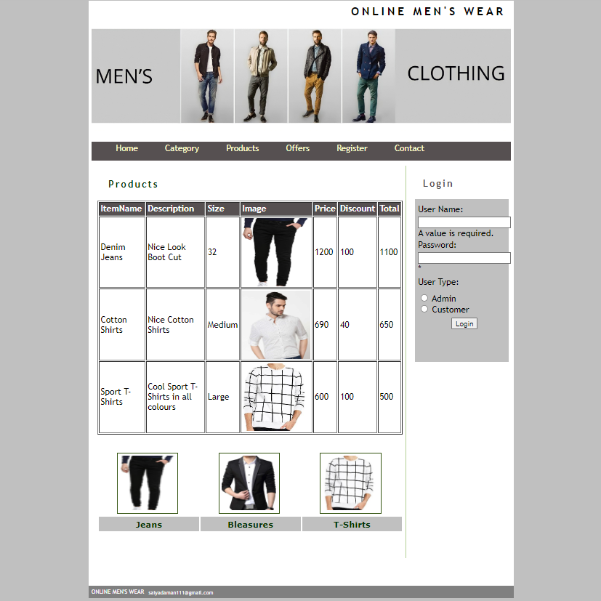

**4. Offers**

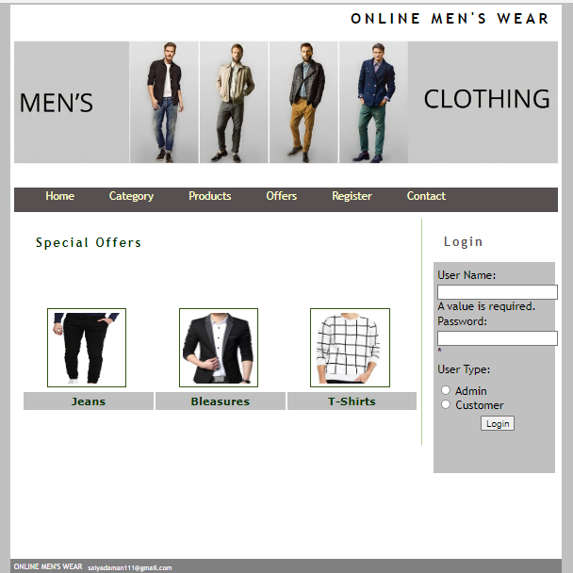

**5. Customer Registration**

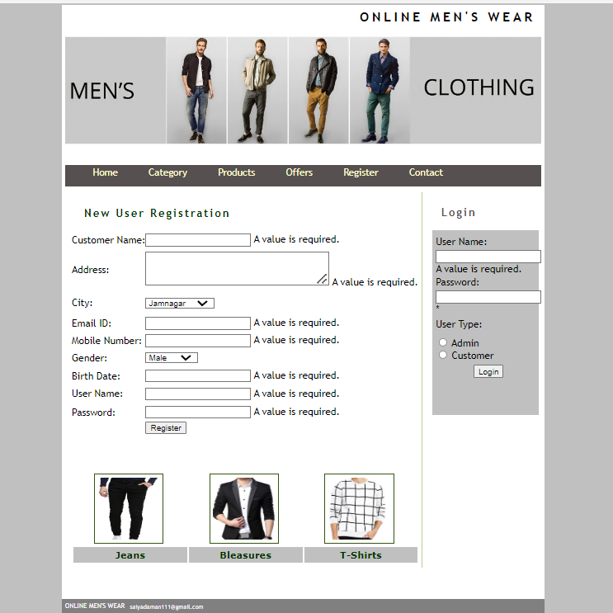

**6. Contact:**

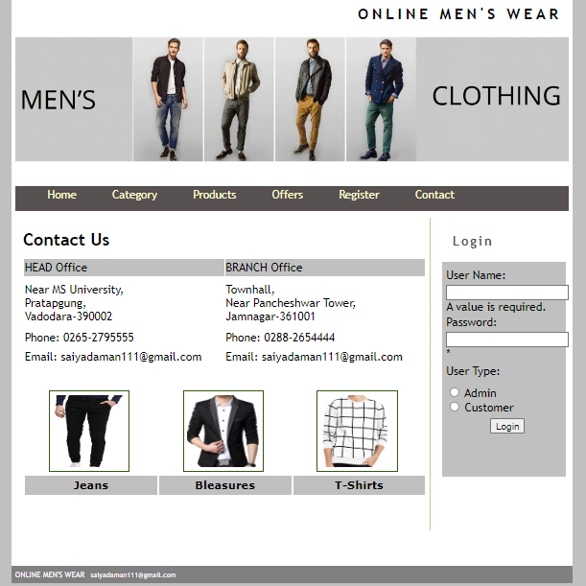

* **Admin Details**

1. **Home Page**

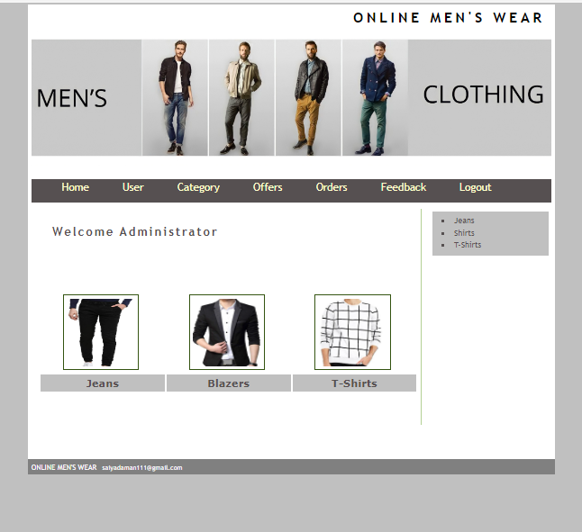

1. **User**

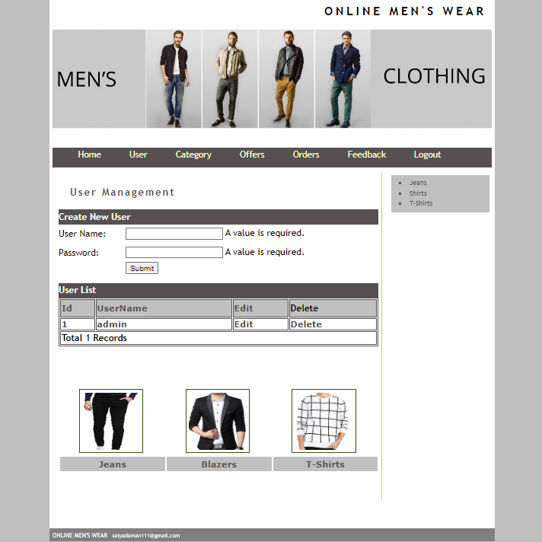

1. **Category**

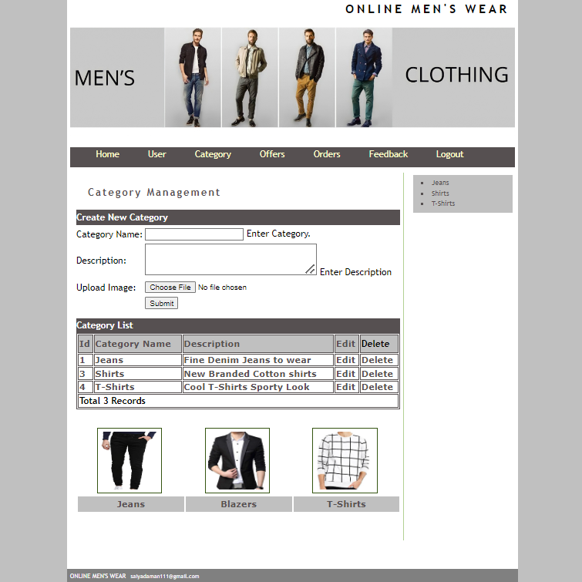

1. **Offer**

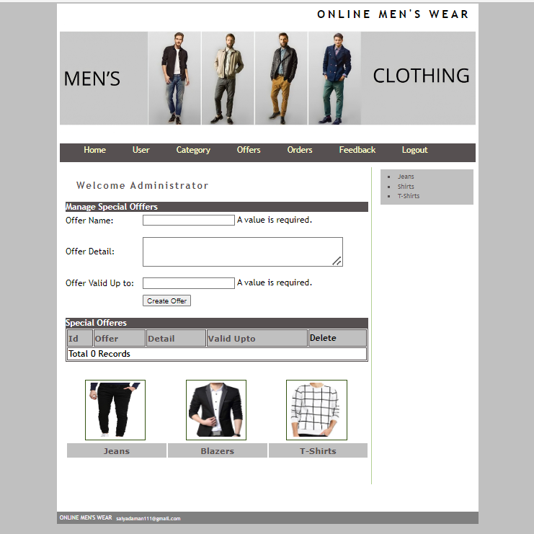

.

1. **Orders**

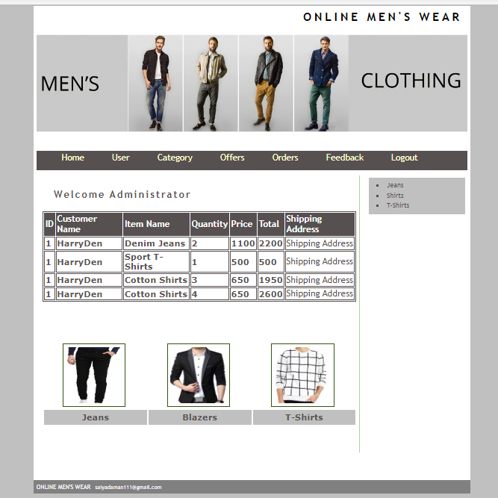

1. **Feedback**

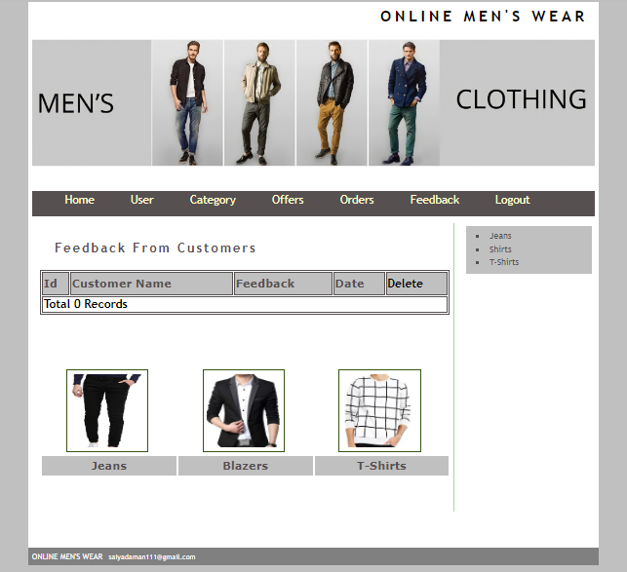

**Customer details**

**1.Home page**

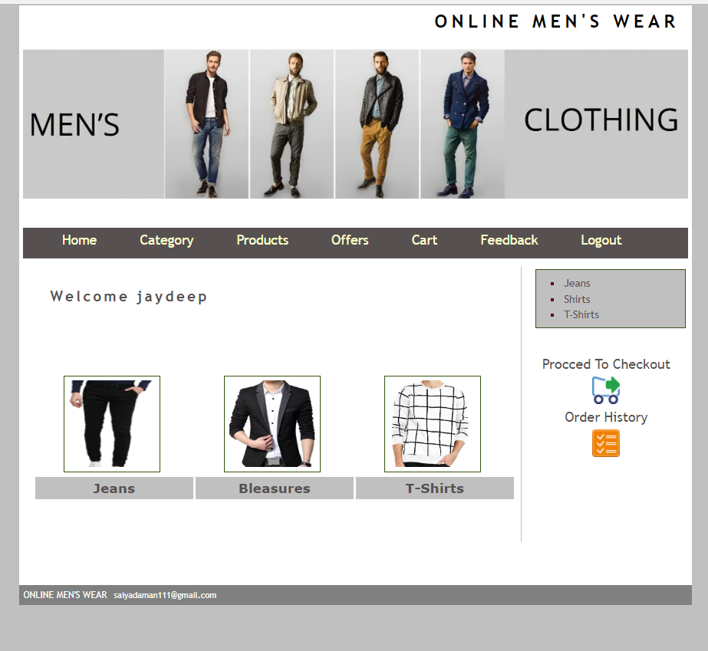

**2.Category**

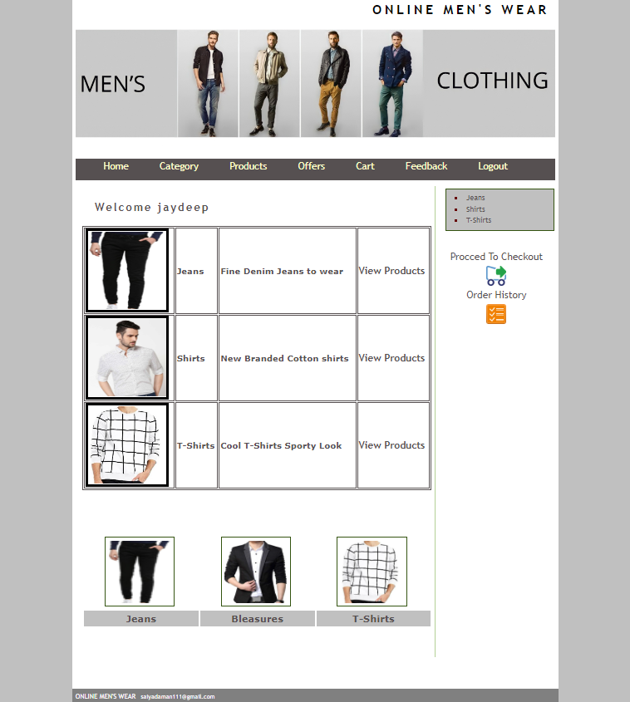

**3.Products**

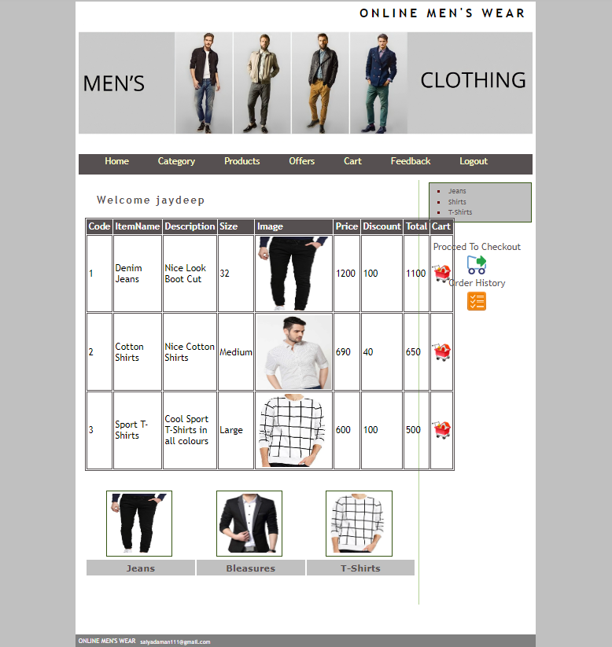

**4.Billing form**

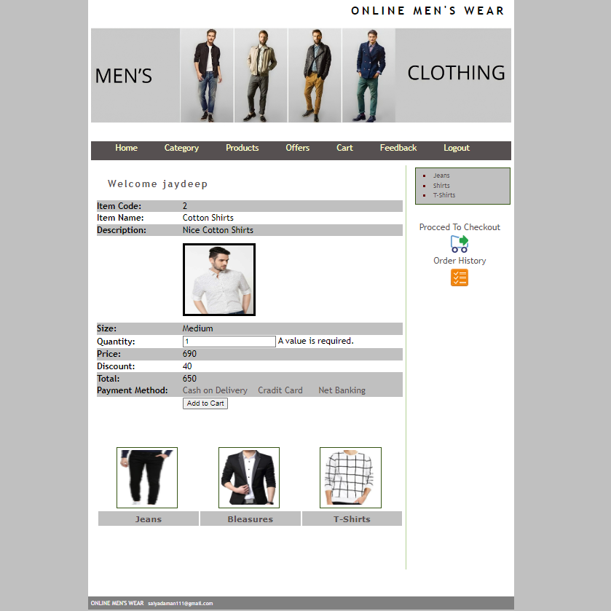

**5. Offer**

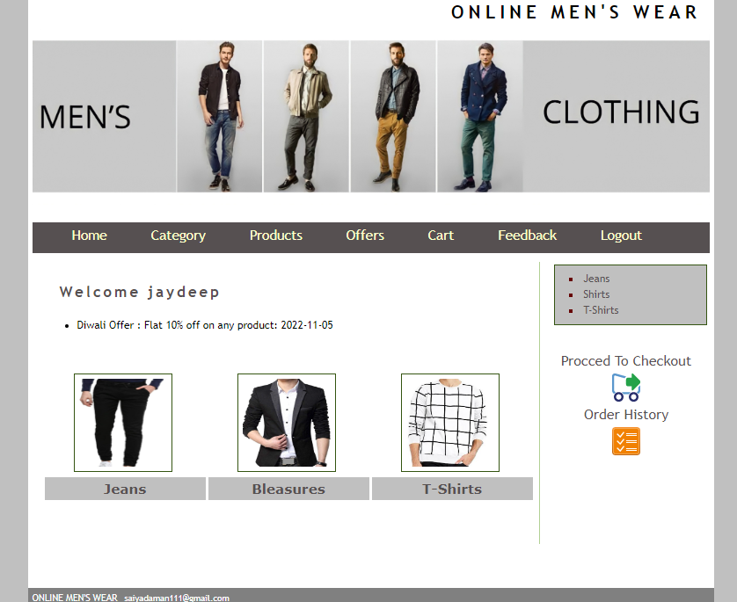

**6.Cart**

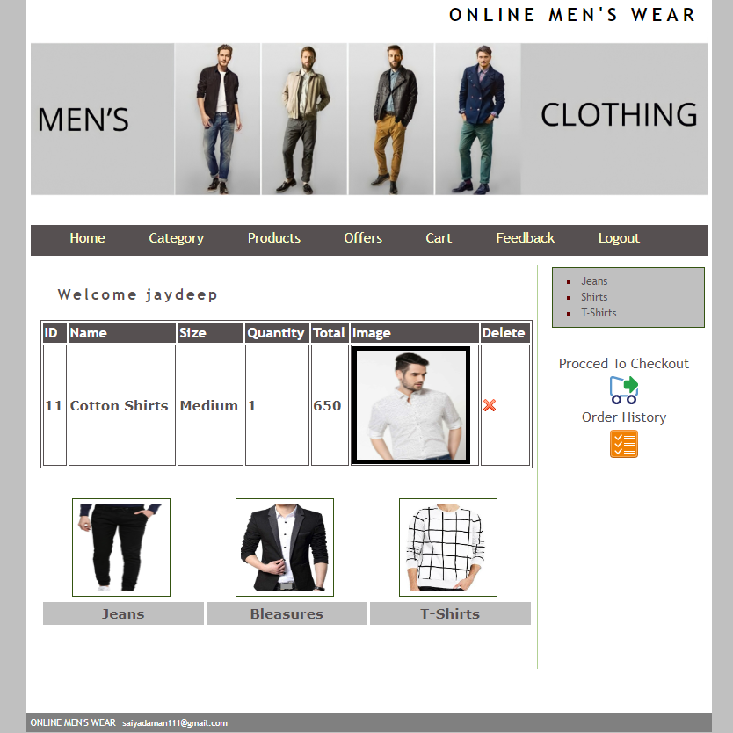

1. **Feedback**

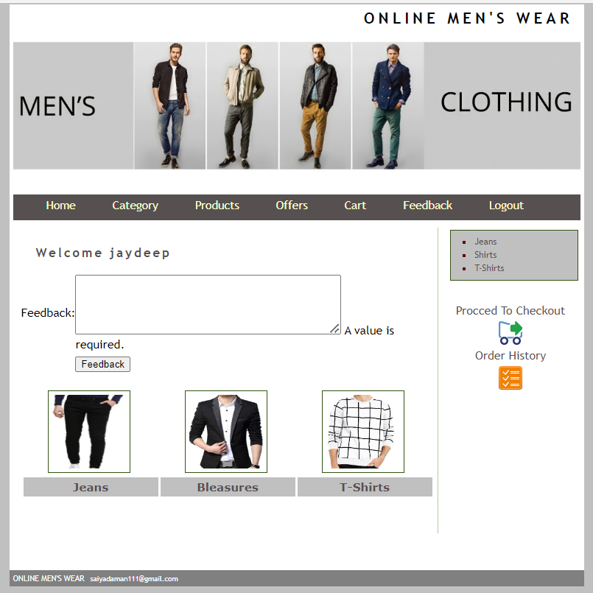

**CHAPTER7**

**LIMITATIONS AND FUTURE ENHANCEMENTS**

**1.LIMITATIONS**

Limitation is the major part of every application & system , in every application there are always some limitations are there . No of any application and software is without any limitation.

Here I have done we try best to solve every limitation but some of the limitation we cannot solve because of the level of our course , time limit , and lack of knowledge . Hence my application has limitation which is given below :

* IT IS ONLY FOR DEMO
* IT DOESN’T GO ONLINE
* MUCH SECURITY IS NOT AVAILABLE

**2. Future Enhancement**

We try to solve project errors . It goes online on internet . Also provide best experience for persons .

This application is not full of every facility , because of limited knowledge and time limits . In future we will try to add more functionality and facilities Creating this application we see many books & Websites .

**CHAPTER 8**

**CONCLUSION**

* The main purpose of this system is to provide branded clothes At reasonable price

**CHAPTER 9**

**BIBLIOGRAPHY**

* The bibliography Contains Reference to All The Document That Were Used To Develop The Web Application

**SITE:**

* [**https://www.w3schools.com**](https://www.w3schools.com)
* [**https://www.PHP.com**](https://www.PHP.com)

**Project:**

* PHP&MYSQL in McGraw Hill
* PHP complete Referce
* PHP jamnadas & Company